**IWP Assignment-2**

**Mayank Dhankar- 20BCE2221**

**CSE-3002-Internet Web Programming**

**Slot-L1+L2**

**Question 1-**

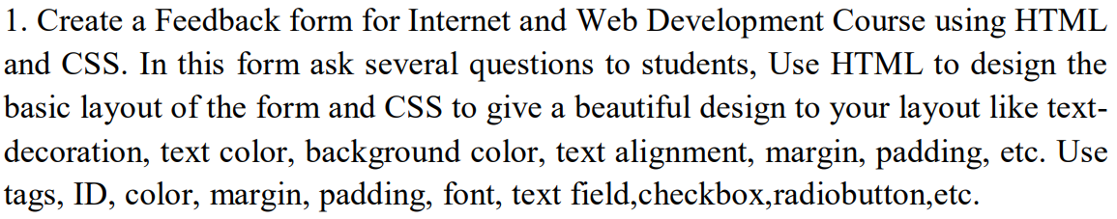

**index.html**

<!DOCTYPE html>

<html lang="en">

<head>

    <meta charset="UTF-8">

    <meta http-equiv="X-UA-Compatible" content="IE=edge">

    <meta name="viewport" content="width=device-width, initial-scale=1.0">

    <title>IWP Feebback Form</title>

    <style>

        body{

            font-family: Arial, Helvetica, sans-serif;

        }

        th{

            background-color: cyan;

        }

        table{

            background-color: lightblue;

            border: 1px white;

        }

        input:invalid {

            border-color: red;

        }

        input:valid {

            border-color: green;

        }

    </style>

</head>

<body>

    <table cellpadding="10" border="1" bordercolor="#ffffff">

        <th colspan="2">IWP Feedback Form</th>

        <tr>

            <td>Registration Form</td>

            <td><input type="text" size="9" placeholder="20BCE2221" required ></td>

        </tr>

        <tr>

            <td>Name</td>

            <td><input type="text" size="30" placeholder="Mayank" required></td>

        </tr>

        <tr>

            <td>Select your Faculty</td>

            <td>

                <select>

                    <option value="">Choose your Faculty</option>

                    <option value="">ARIVOLI A</option>

                    <option value="">MEENAKSHI S P</option>

                    <option value="">JAYAKUMAR K</option>

                    <option value="">KAUSER AHMED P</option>

                    <option value="">MYTHILI T</option>

                    <option value="">LYDIA JANE G</option>

                    <option value="">MARY MEKALA A</option>

                </select>

            </td>

        </tr>

        <th colspan="2">Theory Component</th>

        <tr>

            <td>Select your Theory Slot</td>

            <td>

                <select>

                    <option value="">Choose your Theory Slot</option>

                    <option value="">C1 + TC1</option>

                    <option value="">C2 + TC2</option>

                </select>

            </td>

        </tr>

        <tr>

            <td>Overall Rating Course</td>

            <td>

                <input type="radio">

                <input type="radio">

                <input type="radio">

                <input type="radio">

                <input type="radio">

            </td>

        </tr>

        <tr>

            <td>Which of the course outcome were met</td>

            <td>

                <input type="checkbox">

                <label>Understandable</label>

                <br>

                <input type="checkbox">

                <label>Easily Implementable</label>

                <br>

                <input type="checkbox">

                <label>Readable</label>

                <br>

                <input type="checkbox">

                <label>Percieveable</label>

                <br>

                <input type="checkbox">

                <label>Interesting</label>

            </td>

        </tr>

        <tr>

            <td>How was your over all experience?</td>

            <td><textarea cols="30" rows="5"></textarea></td>

        </tr>

        <tr>

            <td>Any improvements you want us to introduce?</td>

            <td><textarea cols="30" rows="5"></textarea></td>

        </tr>

        <th colspan="2">Lab Component</th>

        <tr>

            <td>Select your Theory Slot</td>

            <td>

                <select>

                    <option value="">Choose your Lab Slot</option>

                    <option value="">L1 + L2</option>

                    <option value="">L45 + L46</option>

                </select>

            </td>

        </tr>

        <tr>

            <td>Overall Rating Course</td>

            <td>

                <input type="radio">

                <input type="radio">

                <input type="radio">

                <input type="radio">

                <input type="radio">

            </td>

        </tr>

        <tr>

            <td>Which of the course outcome were met</td>

            <td>

                <input type="checkbox">

                <label>Understandable</label>

                <br>

                <input type="checkbox">

                <label>Easily Implementable</label>

                <br>

                <input type="checkbox">

                <label>Readable</label>

                <br>

                <input type="checkbox">

                <label>Percieveable</label>

                <br>

                <input type="checkbox">

                <label>Interesting</label>

            </td>

        </tr>

        <tr>

            <td>How was your over all experience?</td>

            <td><textarea cols="30" rows="5"></textarea></td>

        </tr>

        <tr>

            <td>Any improvements you want us to introduce?</td>

            <td><textarea cols="30" rows="5"></textarea></td>

        </tr>

        <th colspan="2"><input type="submit" value="Submit">  <input type="reset" value="Cancel"></th>

    </table>

</body>

</html>

**Output Screenshots**

Combo box to select Faculty and Lab Slot

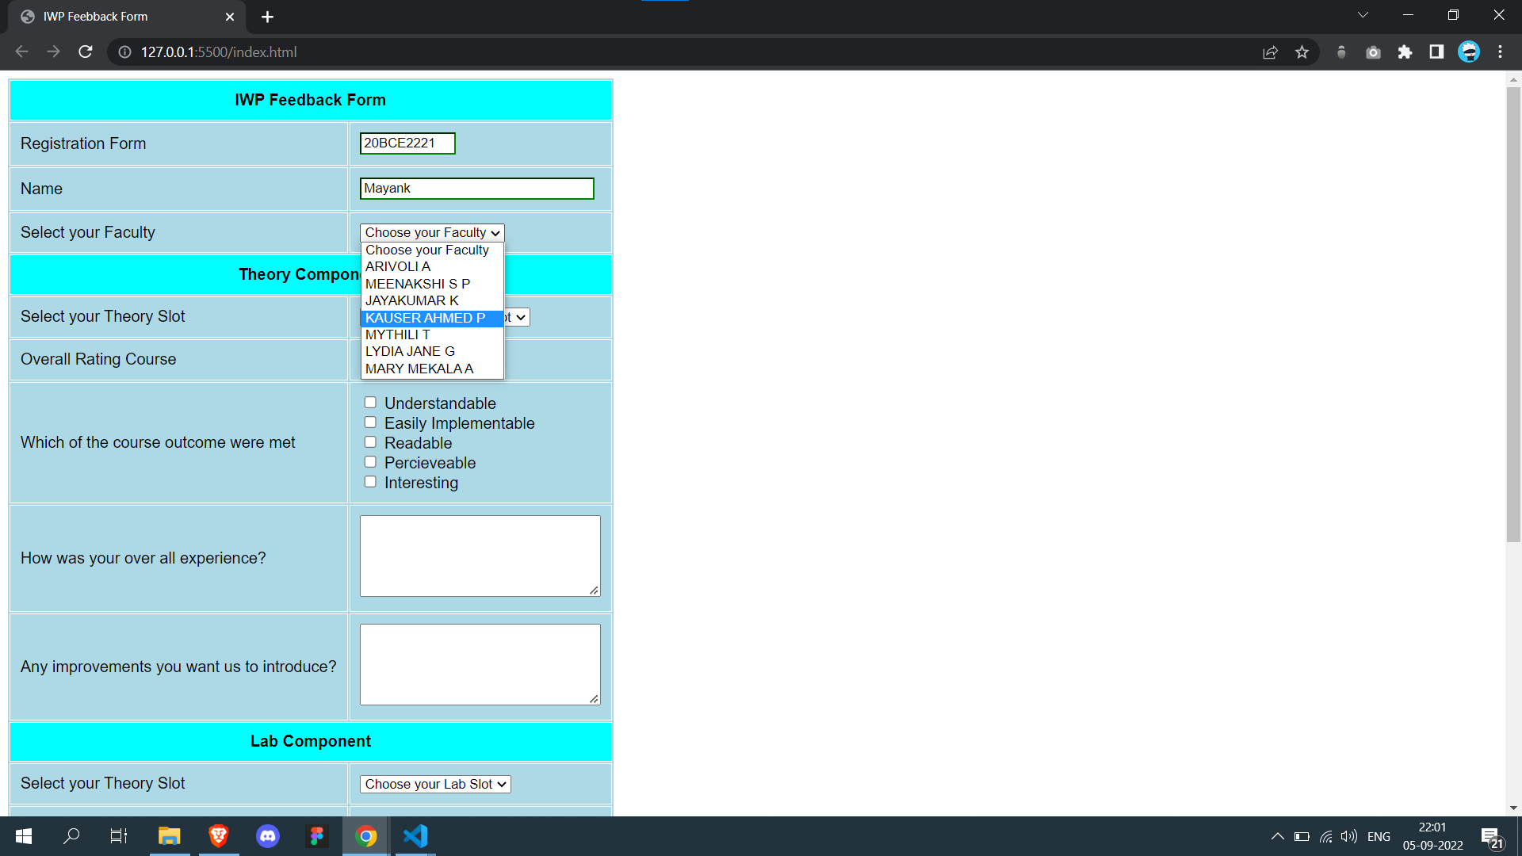

Radio button for rating, checkbox for outcomes and textareafor reviews

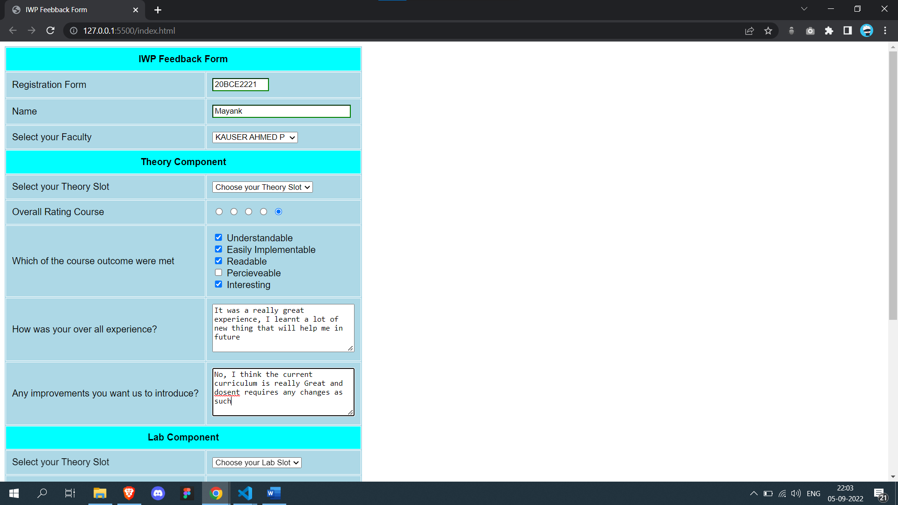

Similar for Lab Slots

**Question 2-**

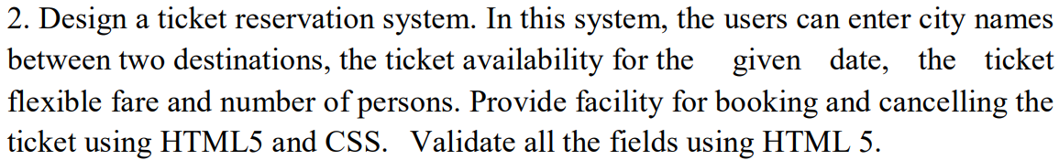

**ticketreservation.html**

<!DOCTYPE html>

<html lang="en">

<head>

    <meta charset="UTF-8">

    <meta http-equiv="X-UA-Compatible" content="IE=edge">

    <meta name="viewport" content="width=device-width, initial-scale=1.0">

    <title>Ticket Reservation</title>

    <script src="https://cdn.tailwindcss.com"></script>

        <link rel="stylesheet" href="abcd.css">

</head>

<body>

    <section class="text-gray-600 body-font">

  <div class="container mx-auto flex px-5 py-3 items-center justify-center flex-col">

    <img class="lg:w-2/6 md:w-3/6 w-5/6 mb-5 object-cover object-center rounded image-hero" alt="hero" src="https://a.cdn-hotels.com/gdcs/production75/d966/8994658f-13ad-4106-bde4-856450359f47.jpg">

    <div class="text-center lg:w-2/3 w-full">

      <h1 class="title-font sm:text-4xl text-xl mb-10 font-medium text-gray-900 heading">Mayank Ticket Resevation System</h1>

      <div class="flex justify-center">

        <div class="relative mb-4 mx-2">

        <label for="email" class="leading-7 text-sm text-gray-600">Pick Up</label>

        <input type="text" id="email" name="email" class="w-full bg-white rounded border border-gray-300 focus:border-indigo-500 focus:ring-2 focus:ring-indigo-200 text-base outline-none text-gray-700 py-1 px-3 leading-8 transition-colors duration-200 ease-in-out">

      </div>

      <div class="relative mb-4 mx-2">

        <label for="email" class="leading-7 text-sm text-gray-600">Destination</label>

        <input type="text" id="email" name="email" class="w-full bg-white rounded border border-gray-300 focus:border-indigo-500 focus:ring-2 focus:ring-indigo-200 text-base outline-none text-gray-700 py-1 px-3 leading-8 transition-colors duration-200 ease-in-out">

      </div>

      </div>

      <div class="flex justify-center">

        <div class="relative mb-4 mx-2">

        <label for="email" class="leading-7 text-sm text-gray-600">From Date</label>

        <input type="date" id="email" name="email" class="w-full bg-white rounded border border-gray-300 focus:border-indigo-500 focus:ring-2 focus:ring-indigo-200 text-base outline-none text-gray-700 py-1 px-3 leading-8 transition-colors duration-200 ease-in-out">

      </div>

      <div class="relative mb-4 mx-2">

        <label for="email" class="leading-7 text-sm text-gray-600">To Date</label>

        <input type="date" id="email" name="email" class="w-full bg-white rounded border border-gray-300 focus:border-indigo-500 focus:ring-2 focus:ring-indigo-200 text-base outline-none text-gray-700 py-1 px-3 leading-8 transition-colors duration-200 ease-in-out">

      </div>

      <div class="relative mb-4 mx-2">

        <label for="email" class="leading-7 text-sm text-gray-600">Number of Person</label>

        <!-- <input type="date" id="email" name="email" class="w-full bg-white rounded border border-gray-300 focus:border-indigo-500 focus:ring-2 focus:ring-indigo-200 text-base outline-none text-gray-700 py-1 px-3 leading-8 transition-colors duration-200 ease-in-out"> -->

        <select class="w-full bg-white rounded border border-gray-300 focus:border-indigo-500 focus:ring-2 focus:ring-indigo-200 text-base outline-none text-gray-700 py-1 px-3 leading-8 transition-colors duration-200 ease-in-out combobox">

            <option value="">1</option>

            <option value="">2</option>

            <option value="">3</option>

            <option value="">4</option>

            <option value="">5</option>

            <option value="">6</option>

            <option value="">7</option>

            <option value="">8</option>

            <option value="">9</option>

            <option value="">10+</option>

        </select>

    </div>

      </div>

    </div>

      <button class="ml-4 my-5 mb-2 inline-flex text-gray-700 bg-gray-100 border-0 py-2 px-6 focus:outline-none hover:bg-purple-400 rounded text-lg"><a href="search.html">Search Flights</a></button>

      <a href="cancel.html"><label for="" class="leading-7 text-md label-heading">Cancel an existing Ticket</label></a>

    </div>

  </div>

</section>

</body>

</html>

**search.html**

<!DOCTYPE html>

<html lang="en">

<head>

    <meta charset="UTF-8">

    <meta http-equiv="X-UA-Compatible" content="IE=edge">

    <meta name="viewport" content="width=device-width, initial-scale=1.0">

    <title>Flight Details</title>

    <script src="https://cdn.tailwindcss.com"></script>

    <link rel="stylesheet" href="abcd.css">

</head>

<body>

    <section class="text-gray-600 body-font">

  <div class="container px-5 py-10 mx-auto">

    <div class="flex flex-col text-center w-full mb-20">

      <h1 class="sm:text-4xl text-3xl font-medium title-font mb-2 text-gray-900">Pricing</h1>

      <p class="lg:w-2/3 mx-auto leading-relaxed text-base">Book some of the best and most affordable flight tickets.</p>

    </div>

    <div class="lg:w-2/3 w-full mx-auto overflow-auto">

      <table class="table-auto w-full text-left whitespace-no-wrap">

        <thead>

          <tr>

            <th class="px-4 py-3 title-font tracking-wider font-medium text-gray-900 text-sm bg-gray-100 rounded-tl rounded-bl">Flight Name</th>

            <th class="px-4 py-3 title-font tracking-wider font-medium text-gray-900 text-sm bg-gray-100">Take Off Time</th>

            <th class="px-4 py-3 title-font tracking-wider font-medium text-gray-900 text-sm bg-gray-100">Landing Time</th>

            <th class="px-4 py-3 title-font tracking-wider font-medium text-gray-900 text-sm bg-gray-100">Price</th>

            <th class="w-10 title-font tracking-wider font-medium text-gray-900 text-sm bg-gray-100 rounded-tr rounded-br"></th>

          </tr>

        </thead>

        <tbody>

          <tr>

            <td class="px-4 py-3">Air India</td>

            <td class="px-4 py-3">05:00</td>

            <td class="px-4 py-3">08:00</td>

            <td class="px-4 py-3 text-lg text-gray-900">₹4700</td>

            <td class="w-10 text-center">

              <input name="plan" type="radio">

            </td>

          </tr>

          <tr>

            <td class="border-t-2 border-gray-200 px-4 py-3">Indigo</td>

            <td class="border-t-2 border-gray-200 px-4 py-3">11:30</td>

            <td class="border-t-2 border-gray-200 px-4 py-3">13:30</td>

            <td class="border-t-2 border-gray-200 px-4 py-3 text-lg text-gray-900">₹7500</td>

            <td class="border-t-2 border-gray-200 w-10 text-center">

              <input name="plan" type="radio">

            </td>

          </tr>

          <tr>

            <td class="border-t-2 border-gray-200 px-4 py-3">Vistara</td>

            <td class="border-t-2 border-gray-200 px-4 py-3">12:00</td>

            <td class="border-t-2 border-gray-200 px-4 py-3">15:00</td>

            <td class="border-t-2 border-gray-200 px-4 py-3 text-lg text-gray-900">₹5400</td>

            <td class="border-t-2 border-gray-200 w-10 text-center">

              <input name="plan" type="radio">

            </td>

          </tr>

          <tr>

            <td class="border-t-2 border-b-2 border-gray-200 px-4 py-3">Indigo</td>

            <td class="border-t-2 border-b-2 border-gray-200 px-4 py-3">14:56</td>

            <td class="border-t-2 border-b-2 border-gray-200 px-4 py-3">17:56</td>

            <td class="border-t-2 border-b-2 border-gray-200 px-4 py-3 text-lg text-gray-900">₹6988</td>

            <td class="border-t-2 border-b-2 border-gray-200 w-10 text-center">

              <input name="plan" type="radio">

            </td>

          </tr>

            <td class="border-t-2 border-b-2 border-gray-200 px-4 py-3">Air India</td>

            <td class="border-t-2 border-b-2 border-gray-200 px-4 py-3">16:30</td>

            <td class="border-t-2 border-b-2 border-gray-200 px-4 py-3">19:30</td>

            <td class="border-t-2 border-b-2 border-gray-200 px-4 py-3 text-lg text-gray-900">₹4940</td>

            <td class="border-t-2 border-b-2 border-gray-200 w-10 text-center">

              <input name="plan" type="radio">

            </td>

          </tr>

            <td class="border-t-2 border-b-2 border-gray-200 px-4 py-3">Vistara</td>

            <td class="border-t-2 border-b-2 border-gray-200 px-4 py-3">20:00</td>

            <td class="border-t-2 border-b-2 border-gray-200 px-4 py-3">23:00</td>

            <td class="border-t-2 border-b-2 border-gray-200 px-4 py-3 text-lg text-gray-900">₹6658</td>

            <td class="border-t-2 border-b-2 border-gray-200 w-10 text-center">

              <input name="plan" type="radio">

            </td>

          </tr>

            <td class="border-t-2 border-b-2 border-gray-200 px-4 py-3">Indigo</td>

            <td class="border-t-2 border-b-2 border-gray-200 px-4 py-3">23:40</td>

            <td class="border-t-2 border-b-2 border-gray-200 px-4 py-3">02:40</td>

            <td class="border-t-2 border-b-2 border-gray-200 px-4 py-3 text-lg text-gray-900">₹8900</td>

            <td class="border-t-2 border-b-2 border-gray-200 w-10 text-center">

              <input name="plan" type="radio">

            </td>

          </tr>

        </tbody>

      </table>

    </div>

    <div class="flex pl-4 mt-4 lg:w-2/3 w-full mx-auto">

      <button class="flex ml-auto text-gray-700 bg-gray-100 border-0 py-2 px-6 focus:outline-none hover:bg-purple-400 rounded">Book Now</button>

    </div>

  </div>

</section>

</body>

</html>

**cancel.html**

<!DOCTYPE html>

<html lang="en">

<head>

    <meta charset="UTF-8">

    <meta http-equiv="X-UA-Compatible" content="IE=edge">

    <meta name="viewport" content="width=device-width, initial-scale=1.0">

    <title>Cancel Ticket</title>

    <script src="https://cdn.tailwindcss.com"></script>

    <link rel="stylesheet" href="abcd.css">

</head>

<body>

    <section class="text-gray-600 body-font">

  <div class="container px-5 py-10 mx-auto">

    <div class="flex flex-col text-center w-full mb-20">

      <h1 class="sm:text-4xl text-3xl font-medium title-font mb-2 text-gray-900">Cancel</h1>

      <p class="lg:w-2/3 mx-auto leading-relaxed text-base">We are sorry to see you cancel a flight, but have a nice day.</p>

    </div>

    <div class="lg:w-2/3 w-full mx-auto overflow-auto">

      <table class="table-auto w-full text-left whitespace-no-wrap">

        <thead>

          <tr>

            <th class="px-4 py-3 title-font tracking-wider font-medium text-gray-900 text-sm bg-gray-100 rounded-tl rounded-bl">Flight Name</th>

            <th class="px-4 py-3 title-font tracking-wider font-medium text-gray-900 text-sm bg-gray-100">Take Off Date</th>

            <th class="px-4 py-3 title-font tracking-wider font-medium text-gray-900 text-sm bg-gray-100">Take Off Time</th>

            <th class="px-4 py-3 title-font tracking-wider font-medium text-gray-900 text-sm bg-gray-100">Status</th>

            <th class="w-10 title-font tracking-wider font-medium text-gray-900 text-sm bg-gray-100 rounded-tr rounded-br"></th>

          </tr>

        </thead>

        <tbody>

          <tr>

            <td class="px-4 py-3">Air India</td>

            <td class="px-4 py-3">5 Sept</td>

            <td class="px-4 py-3">08:00</td>

            <td class="px-4 py-3 text-lg text-gray-900">Ontime</td>

            <td class="w-10 text-center">

              <input name="plan" type="radio">

            </td>

          </tr>

          <tr>

            <td class="border-t-2 border-gray-200 px-4 py-3">Indigo</td>

            <td class="border-t-2 border-gray-200 px-4 py-3">15 Sept</td>

            <td class="border-t-2 border-gray-200 px-4 py-3">13:30</td>

            <td class="border-t-2 border-gray-200 px-4 py-3 text-lg text-gray-900">Ontime</td>

            <td class="border-t-2 border-gray-200 w-10 text-center">

              <input name="plan" type="radio">

            </td>

          </tr>

          <tr>

        </tbody>

      </table>

    </div>

    <div class="flex pl-4 mt-4 lg:w-2/3 w-full mx-auto">

      <button class="flex ml-auto text-gray-700 bg-gray-100 border-0 py-2 px-6 focus:outline-none hover:bg-purple-400 rounded">Cancel</button>

    </div>

  </div>

</section>

</body>

</html>

**abcd.css**

body {

    background-color: lightblue;

}

.heading {

    font-weight: 700;

    font-size: 3rem;

    color: white;

}

.label-heading {

    font-size: 1.2rem;

    font-weight: 500;

}

.label-heading:hover{

    text-decoration: underline;

    color: blueviolet   ;

}

.combobox{

    height: 45px;

}

**Output Screenshots**

Main Landing Page

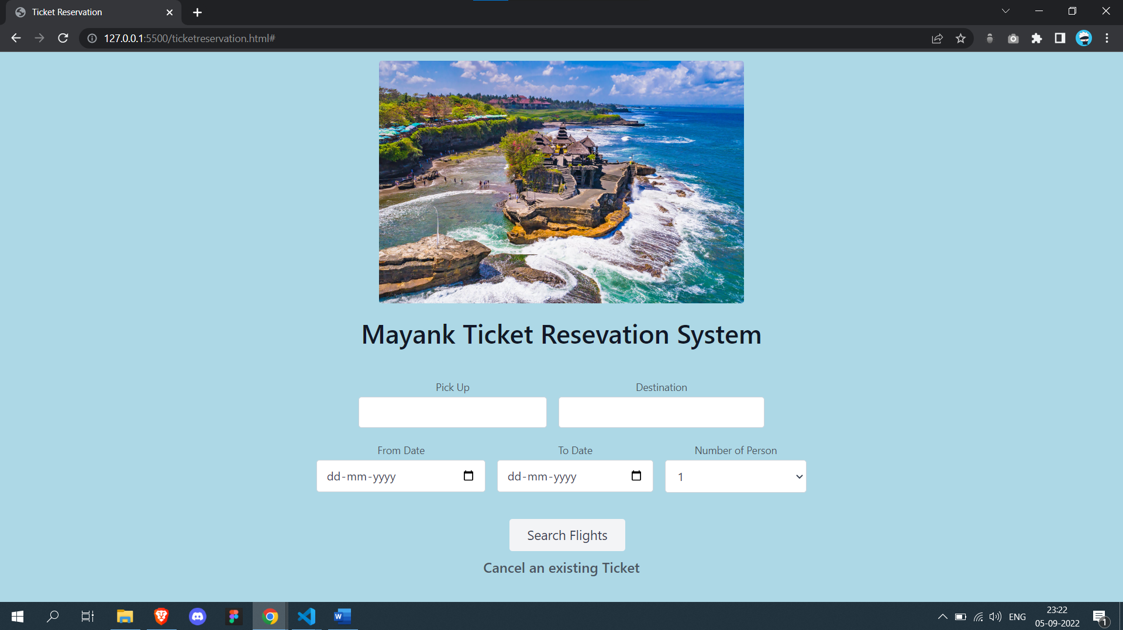

Select Dates

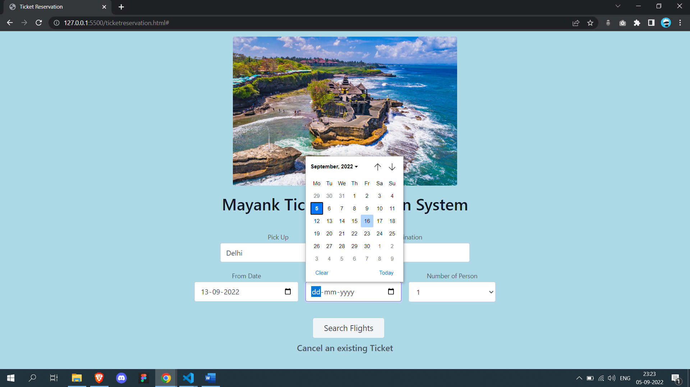

Select no of persons

Purple color button on hover

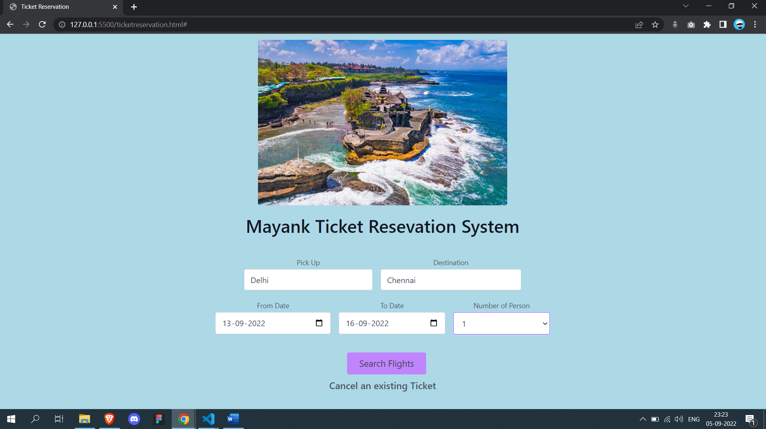

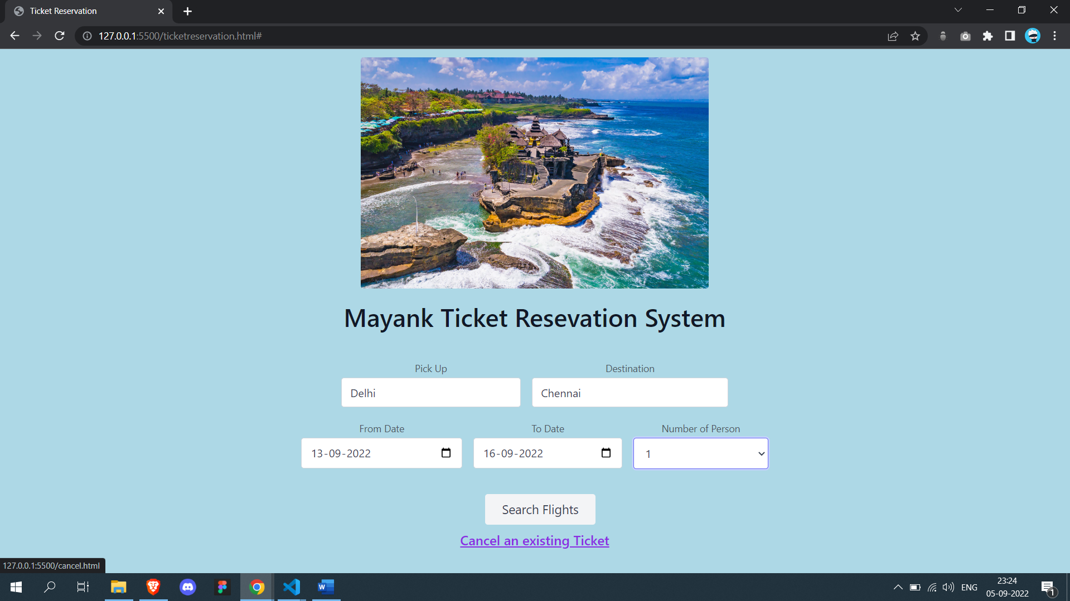

List of flights

Purple on hover and selected flight for buying ticket

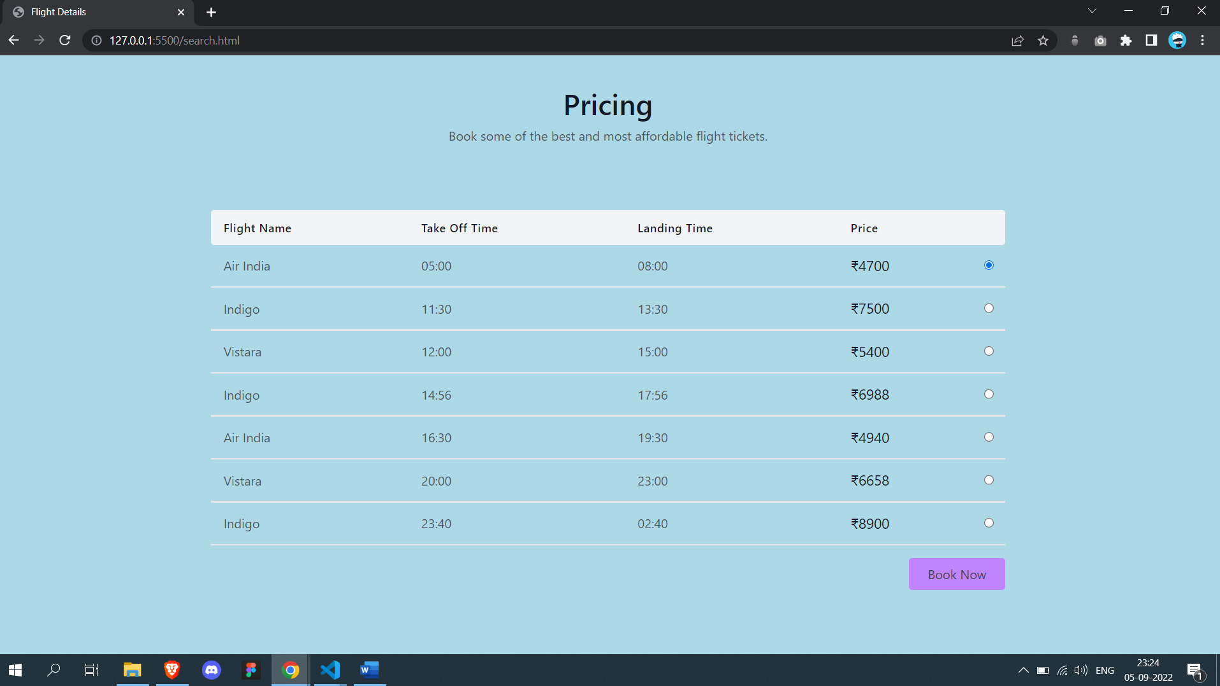

List of flights available for cancelation

Purple color on hover

